**The Hermitage Schools**

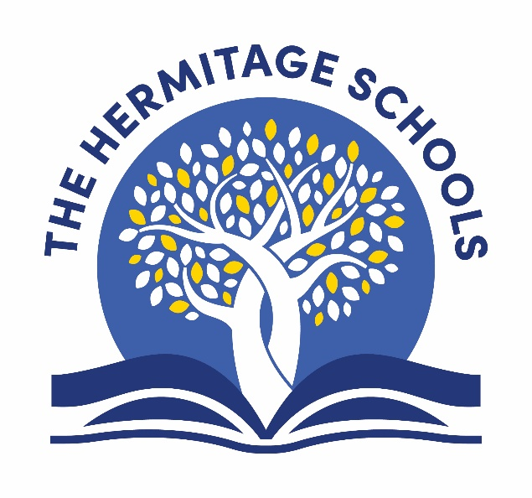

**A Guide to**

**Healthy Lunchboxes**

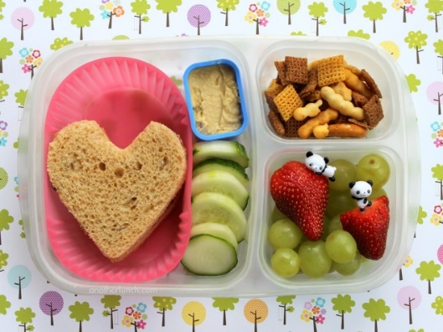

**Healthy Lunchboxes**

We have adopted the recommendations from the British Nutrition Foundation for children with packed lunches. We know that most of you are providing your child with a healthy lunch, but you might like some new ideas.

Choose a variety of foods from the first four main groups for the bulk of your child’s lunch, foods from the fifth group can be added in small amounts or as occasional treats.

1. Carbohydrate
2. Protein
3. Fruit and vegetables
4. Dairy
5. Foods containing fat and/or sugar.

**Carbohydrate Group**

Wholemeal/multigrain and white bread, rolls, Pitta bread, Bagel, French bread, Scottish pancake, English muffins, fruit scones, malt loaf, Matzo, crispbreads, crackers, pasta and rice salads.

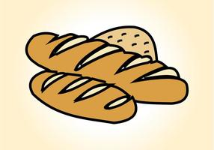

**Fruit and Vegetables**

Salad in sandwiches and rolls, salads, fresh fruit, tinned fruit (in juice rather than syrup), dried fruit.



**Protein Group**

Slices of ham, chicken turkey (try avoiding fatty cold meats like salami type meats), boiled eggs, canned tuna and salmon, prawns, hummus.

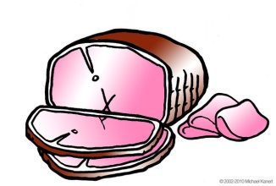



**Dairy Group**

Edam, Cheddar, Cheese triangles, soft cheese, fruit yogurts, fromage frais, drinking yogurts, pots of rice pudding.

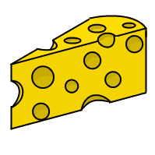



**Drink**

Fruit smoothies, pure fruit juices, milk, sugar free squash and water.





**ALLERGY ALERT**

